**EMMI ORU *Unsolicited* Cerner Reqs**

**Version 1.1**

**Prepared By: Sarah Thies & Tom Fredrickson**

**Date: 12/1/2016**

Document Control 3

Resources 3

Project Distribution List 3

Document Version Control 3

1. Introduction 4

1.1 Purpose 4

1.2 Project Scope 4

1.3 Terminology Standards 4

1.3.1 Acronyms 4

1.3.2 Glossary 4

1.4 Document References 4

2. Diagram 5

3. Requirements 6

3.1 Functional Requirements (Cerner FSI) 6

3.2 Non-Functional Requirements 6

3.3 Messaging Protocols 6

3.3.1 Inbound to the BayCare Cloverleaf 6

3.3.2 Outbound to the BayCare Cloverleaf 6

3.3.3 Inbound to the Vendor 7

3.3.4 Outbound to the Vendor 7

3.3.5 Inbound to the BayCare Cerner EMR 7

3.3.6 Outbound BayCare Cerner to Cloverleaf 7

4. HL7 Messaging 7

4.1 Messaging Format 7

4.1.1 Segments 7

4.1*.*2 Messaging Event Types 8

4.1*.*3 Cloverleaf Configuration Files 8

4.1.4 Cloverleaf Site Location 8

4.2 Data Transformation Requirements 9

4.3 Sample Messages 9

5. Testing 10

5.1. Unit Testing Scenarios 12

5.2 Integrated Testing Scenarios 12

5.3 Testing Approvals 12

5.4 Piloting 13

5.5 Approvals - Please see Monica Bousbar in the Lab 13

6. Deployment / Implementation Model 13

Appendix A: Risks and Concerns 13

Appendix B: Issues List 13

# **Document Control**

## Resources

|  |  |  |
| --- | --- | --- |
| **Name** | **Role** | **Email** |
| Thies, Sarah | BayCare FSI Developer | Sarah.Thies@baycare.org |
| Fredrickson II, Thomas | BayCare Cloverleaf Developer | Thomas.Fredrickson@baycare.org |
| Patel, Chirayu | BayCare Sr. Systems Analyst | [Chirayu.Patel@baycare.org](mailto:Chirayu.Patel@baycare.org) |
| Marshall, Abbie | BayCare Systems Analyst | Abbie.Marshall@baycare.org |
| Gwozdz, Bryan | BayCare Sr. Systems Analyst, Data Warehouse & Business Intelligence | Bryan.Gwozdz@BayCare.org |
| Gitney, Nicole | BayCare Director Nursing Informatics | [nicole.gitney@baycare.org](mailto:nicole.gitney@baycare.org) |
|  |  |  |
| Cook, Brian | EMMI Interface Specialist | [bcook@emmisolutions.com](mailto:bcook@emmisolutions.com) |
| Rabkin, Dana | EMMI Project Manager | drabkin@emmisolutions.com |
| RYZNER, SZYMON | EMMI Product Manager | [sryzner@emmisolutions.com](mailto:sryzner@emmisolutions.com) |
|  |  |  |
|  |  |  |

## Project Distribution List

## Document Version Control

|  |  |  |  |
| --- | --- | --- | --- |
| **Version** | **Date** | **Modifier** | **Description** |
| V1.0 | 11/10/2016 | Sarah Thies | Originally Created |
| V1.1 | 12/1/2016 | Tom Fredrickson | Added Cloverleaf Details |
|  |  |  |  |
|  |  |  |  |

# 1. Introduction

## 1.1 Purpose

The EMMI Application provides educational videos to the patient’s **home** email address prior to the patient’s appointment. This document outlines the BayCare data warehouse surgery and radiology batch files sent to EMMI that will in turn send the **unsolicited** results to Cerner.

## 1.2 Project Scope

EMMI will send **unsolicited** results via Cloverleaf that will pass through the **existing** GetWell Network Results Inbound Interface to Cerner.

## 1.3 Terminology Standards

### 1.3.1 Acronyms

MLLP – Minimum Lower Layer Protocol for messaging framing a HL7 message.

### 1.3.2 Glossary

List the terms that require definition

## 1.4 Document References

**Cerner Specifications:**

<https://wiki.ucern.com/display/public/reference/Unit+10i+-+Result+and+Document+Processing+Inbound>

**EMMI Documents/Specifications:**

Per Brian from EMMI:

Below is a table with the OBX vales EMMI will be sending in the results messages..

|  |  |  |
| --- | --- | --- |
| **Baycare Event Set/Code** | **Emmi Code (OBX-3.1)** | **Emmi Description (OBX-3.2)** |
| EMMI Program | EMMIEDU | Education |
|  | EMMIURL | Emmi URL |
|  | EMMIACC | Emmi Access Code |
|  | EMMIISSUEDATE | Emmi Issue Date |
|  | EMMISTARTDATE | Emmi Start Date |
| EMMI Completed Date | EMMICOMPDATE | Emmi Completed Date |
| EMMI View-by-Date | EMMIEXPDATE | Emmi Expiration Date |
| EMMI Status | EMMIEVENT | Emmi Message Event |

Per Chirayu:

As we only need below info to show for our EMMI Results in CERNER, I have removed rest of the things:

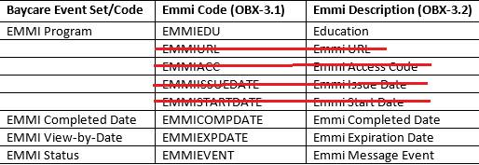

# 2. Diagram

***BayCare*** Data Warehouse Extract File

# 3. Requirements

## 3.1 Functional Requirements (Cerner FSI)

Provide detail for the below functional requirements. The message transformation requirements for the components defined in this specification should be specified in section 4.2 of this document.

|  |  |  |
| --- | --- | --- |
| **Cerner** |  |  |
| **Number** | **Requirement Name** | **Requirement Description** |
| FR.2016.1.0 | CPI | The BayCare CPI value will be sent via Cloverleaf in field PID-3 with identifier type in field PID-3.5 containing value BCCPI. |
| FR.2016.2.0 | FIN | The BayCare FIN value will be sent via Cloverleaf in field PID-18.1 with identifier type in field PID-18.5 containing value BCFN. |

## 3.2 Non-Functional Requirements

Provide concise detail for the below non-functional requirements. The below requirements must be evaluated for every project.

|  |  |  |
| --- | --- | --- |
| **Cerner** |  |  |
| **Number** | **Requirement Name** | **Requirement Description** |
| NFR.2015.1.0 | Click here to enter text. | Click here to enter text. |

## 3.3 Messaging Protocols

Below are listed the details for the messaging protocols that will be leveraged for this integration. Please see the reference document located on the Integration SharePoint server: <insert link to document here>

### 3.3.1 Inbound to the BayCare Cloverleaf

**Production**

**Host IP:** 10.5.250.201

**Port:** 23253

**Test**

**Host IP:** 10.5.250.203

**Port:** 23253

**Site:** patient_ed_11

**Route:** oru_emmi_in 🡪 oru_cer_out

### 3.3.2 Outbound to the BayCare Cloverleaf

### 3.3.3 Inbound to the Vendor

Click here to enter text.

### 3.3.4 Outbound to the Vendor

* Click here to enter text.

### 3.3.5 Inbound to the BayCare Cerner EMR

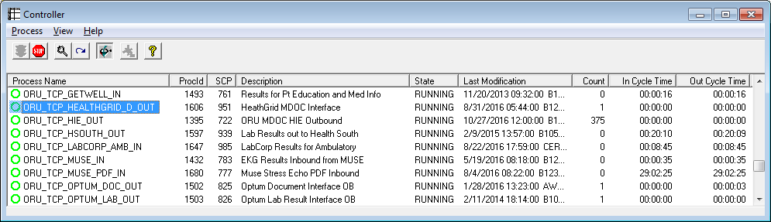

**M30**

Port Number: 10020

**P30**

Port Number: 10056

### 3.3.6 Outbound BayCare Cerner to Cloverleaf

# 4. HL7 Messaging

## 4.1 Messaging Format

### 4.1.1 Segments

The segments utilized for the ORU interface are:

MSH

PID

[PV1]

{

ORC

OBR

[{NTE}]

*Message Construction Notes:*

*[Square Brackets] – Optional*

*{Curly Brackets} – Repeatable*

*MSH – Message Header*

*EVN – Event segment*

*PID – Patient ID segment*

*PV1 – Patient Visit segment*

*ORC – Common Order segment*

*IN1 – Insurance segment*

*[{ – Start of optional, repeatable group*

*}] – End of optional, repeatable group*

### 4.1*.*2 Messaging Event Types

Below is the messages type necessary for this integration

|  |  |
| --- | --- |
| **Event Type** | **Description** |
| ORU^R01 | Result |

### 4.1*.*3 Cloverleaf Configuration Files

For each HL7 interface specified in Section 2 of this document, identify the Cloverleaf Configuration Files: Variants, TCL Scripts, Xlates, etc.

Here is what the Cloverleaf Xlate emmi_cerner_oru.xlt does:   
BULKCOPY   
PID-3.2 Blanked out.   
BCCPI --> PID-3.5   
PID-18.4 Blanked out.   
BCFN --> PID-18.5

### 4.1.4 Cloverleaf Site Location

**Results**

**Site:** **patient_ed_11**

Route: **oru_emmi_in 🡪 oru_cer_out**

## 4.2 Data Transformation Requirements

|  |  |  |  |  |  |
| --- | --- | --- | --- | --- | --- |
| **Field Description** | **HL7 Field Loc.** | **Required Y/N** | **Data Type** | **Length** | **Notes** |
| Patient Identifier Type | PID-3.5 | Y | ID | 20 | Value is BCCPI to identify the CPI number |
| Patient Account Number Type | PID-18.5 | Y | ID | 20 | Value is BCFN to identify the FIN number |

## 4.3 Sample Messages

**Cerner**

**Inbound Cerner *Result*:**

10/31/2016, EMMI sending ***unsolicited*** result back to Cerner via GWN Results IN

MSH|^~\&|GWN|GWN|HNAM|BAYCARE|20161031153438||ORU^R01|20161031153438782|T|2.3

PID|1||810007515^^^^BCCPI||EMMIBATCH^INTEGRATION||19710101|M||||||||||6000023714^^^^BCFN

ORC|RE||15298886050||||||||||||20161031144418350||EMMI SOLUTIONS

OBR|1||15298886050|EMMIEDU|||201610311444|||||||||||||||201610311534|||F

OBX|1|ST|EMMIEDU^Education||COLONOSCOPY||||||F

OBX|2|ST|EMMICOMPDATE^Emmi Completed Date||||||||F

OBX|3|ST|EMMIEXPDATE^Emmi Expiration Date||Nov 18, 2016||||||F

OBX|4|ST|EMMIEVENT^Emmi Message Event||Scheduled||||||F

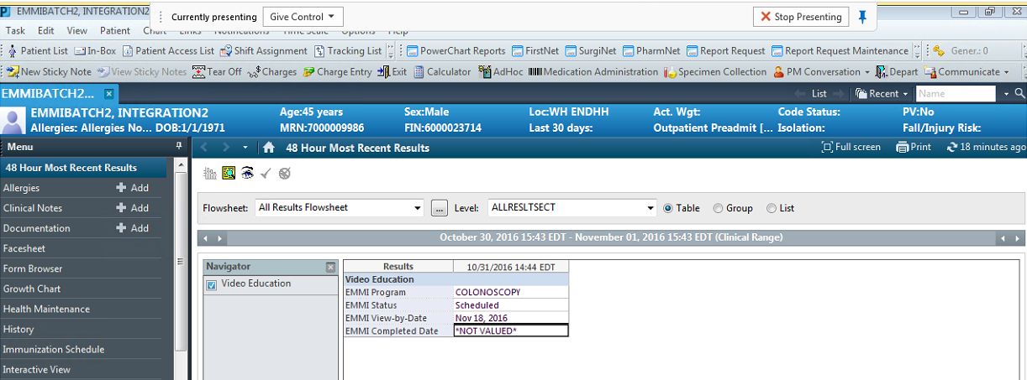

***Note:***

Error Stat ESI_STAT_WARNING

Error Text No order_id found for order complete for result message.

*SAME* **AS PROD TODAY** for *unsolicited* pharmacy results

# **5. Testing**

|  |  |  |
| --- | --- | --- |
| **Steps** | **Details** | **Fail/Pass** |
| 1 | Register Test Patient (i.e. **FIN 6000023778**) | Pass |
| 2 | Scheduled "Radiology" Procedure (i.e. **Procedure** = **CT Guided Biopsy Lung** & **Schedule Date** = **11/24/2016**) | Pass |
| 3 | Did EMMI received the Data for this "Radiology" procedure which is scheduled on this Test Patient | Pass |
| 4 | Did EMMI processed the file successfully | Pass |
| 5 | Check if the Test Patient got EMAIL to watch the Video | Pass |
| 6 | Check in PowerChart if the RESULT is showing as below: * EMMI Program = **CT SCAN** * EMMI Status = **Scheduled** * EMMI View-by-Date = **Nov 24, 2016** * EMMI Completed Date = **\*NOT VALUED\*** | Pass |
| 7 | Open EMAIL and click the link and watch the whole video | Pass |
| 8 | Check in PowerChart if the RESULT is showing as below: * EMMI Program = **CT SCAN** * EMMI Status = **Completed (c)** * EMMI View-by-Date = **Nov 24, 2016** * EMMI Completed Date = **Nov 07, 2016 (c)** | Pass |
|  |  |  |
|  | **\*\*\* Received below EMAIL from EMMI after file was processed \*\*\*** |  |
| |  | | --- | |  | |  |  |
|  |  |  |
|  |  |  |
|  |  |  |
|  |  |  |
|  |  |  |
|  |  |  |
|  |  |  |
|  |  |  |
|  |  |  |
|  |  |  |
|  |  |  |
|  |  |  |
|  |  |  |
|  |  |  |
|  |  |  |
|  |  |  |
|  |  |  |
|  |  |  |
|  |  |  |
|  |  |  |
|  |  |  |
|  | **\*\*\* After the File was processed by EMMI and also EMAIL received by patient, checked Patient's chart and it shows the RESULT's correctly \*\*\*** |  |
|  |  |  |
|  |  |  |
|  |  |  |
|  | **\*\*\* RESULT's are showing correctly, after the EMMI PROGRAM was COMPLETED (i.e. Patient watched whole EMMI Program video) \*\*\*** |  |
|  | |  | | --- | |  | |  |
|  |  |  |
|  |  |  |
|  |  |  |
|  |  |  |
|  |  |  |
|  |  |  |
|  |  |  |
|  |  |  |
|  |  |  |
|  |  |  |
|  |  |  |
|  |  |  |
|  |  |  |
|  |  |  |

## 5.1. Unit Testing Scenarios

|  |  |
| --- | --- |
| **Scenario** | **Expected Result** |
|  |  |
|  |  |
|  |  |

## 5.2 Integrated Testing Scenarios

|  |  |
| --- | --- |
| **Scenario** | **Expected Result** |
|  |  |
|  |  |

## 5.3 Testing Approvals

|  |  |  |  |
| --- | --- | --- | --- |
| **Testing Phase** | **Date** | **Department** | **Team Member** |
| PH1.UNIT |  |  |  |
| PH1.INTEGRATED |  |  |  |

## 5.4 Piloting

NA

## 5.5 Approvals - Please see Monica Bousbar in the Lab

|  |  |  |  |
| --- | --- | --- | --- |
| **Testing Phase** | **Date** | **Department** | **Team Member** |
| PH1.0 |  |  |  |
|  |  |  |  |
|  |  |  |  |

# 6. Deployment / Implementation Model

***GO LIVE*** 11/30/2016

# Appendix A: Risks and Concerns

|  |  |  |  |  |  |  |  |  |
| --- | --- | --- | --- | --- | --- | --- | --- | --- |
| **Project Name** |  |  | | |  |  |  |  |
| **Number** | **Risk / Concern** | **Comment** | **Mitigation** | | |  |  |  |
| RC.2013.1.0 |  |  | |  | |  |  |  |

# Appendix B: Issues List

This is a dynamic list of the open issues related to the IDBB that remain to be solved, including but not limited to TBDs, pending decisions, information needed, conflict awaiting resolution, and the like.

|  |  |  |  |  |  |  |  |  |
| --- | --- | --- | --- | --- | --- | --- | --- | --- |
| **Project Name** |  |  | | |  |  |  |  |
| **Number** | **Issue** | **Comment** | **Fix** | | |  |  |  |
| I.2013.1.0 |  |  | |  | |  |  |  |

* End of document